Click the ‘Download OpenVPN_Server_FlexEdge.zip’ button.
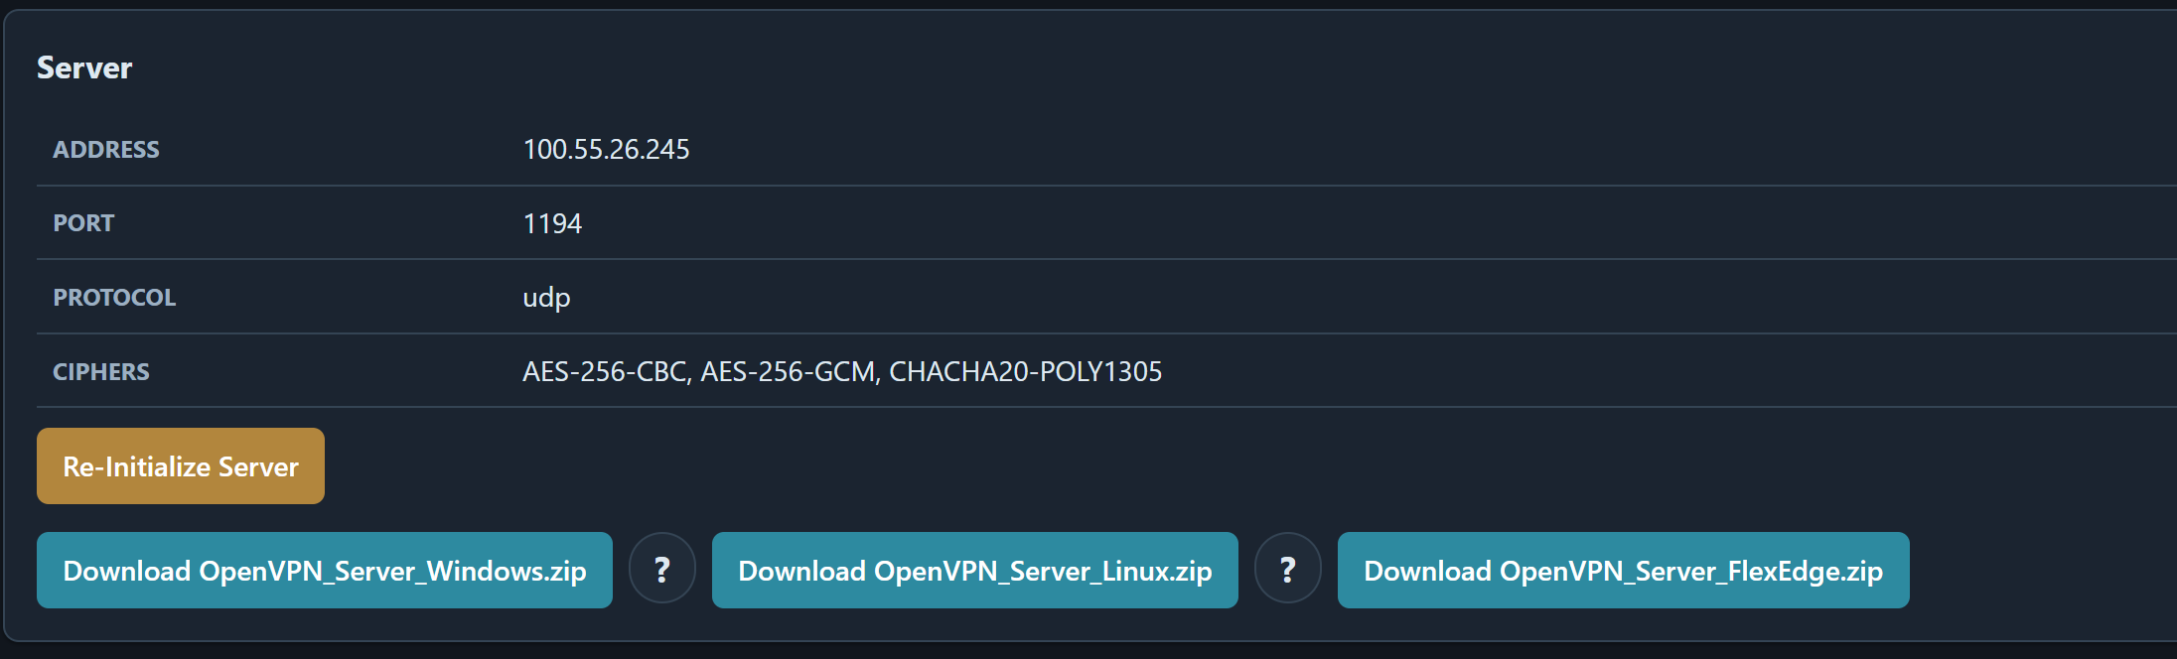
Extract the ZIP file
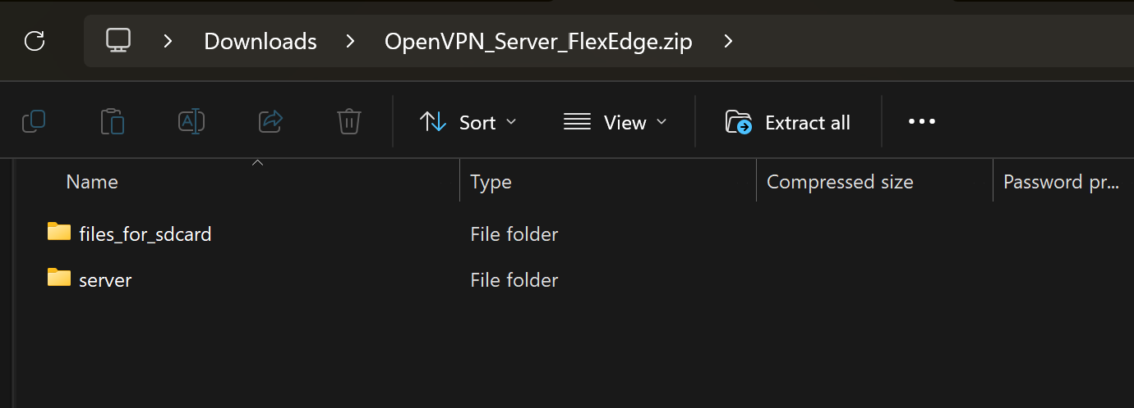
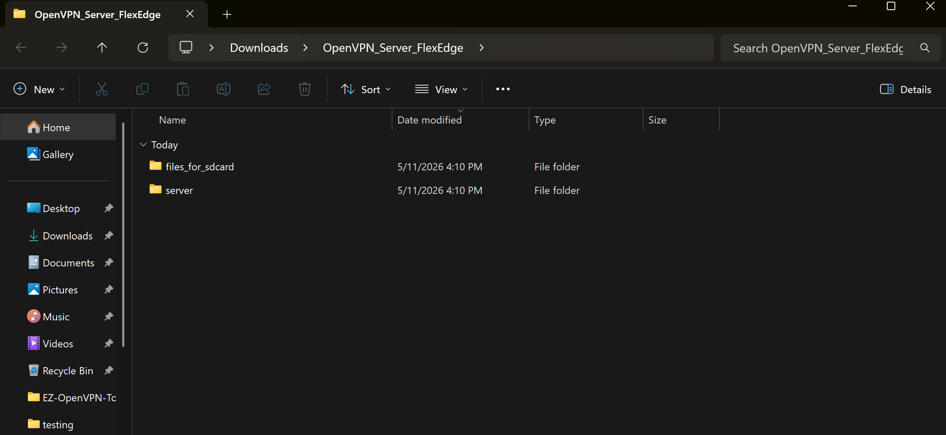

NOTE: Ensure that FTP access is enabled under:
Configuration > System Configuration > Services > FTP Server
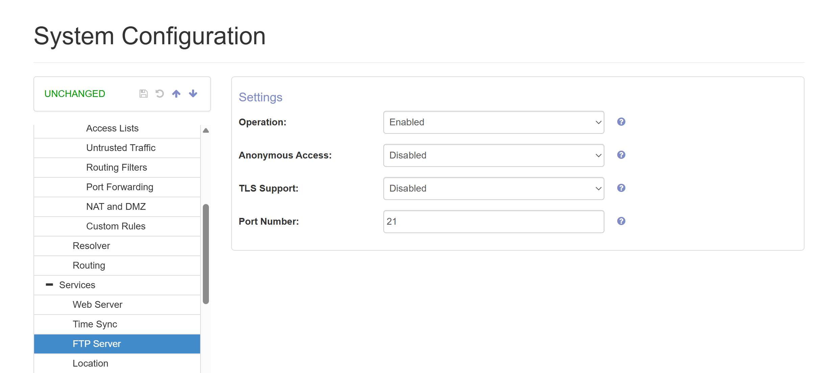

Using an FTP client such as WinSCP, log in using the same credentials as the FlexEdge web GUI.
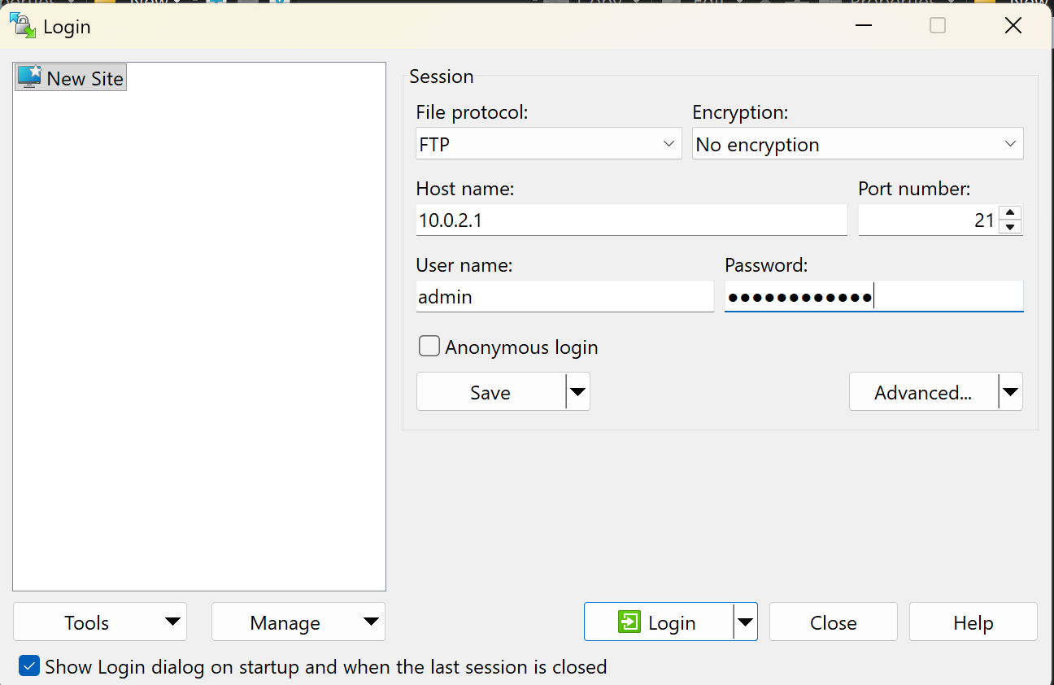

Open the ‘Files for SD Card’ folder and navigate to Drive-E on the FlexEdge. Drive-E represents the SD card filesystem.
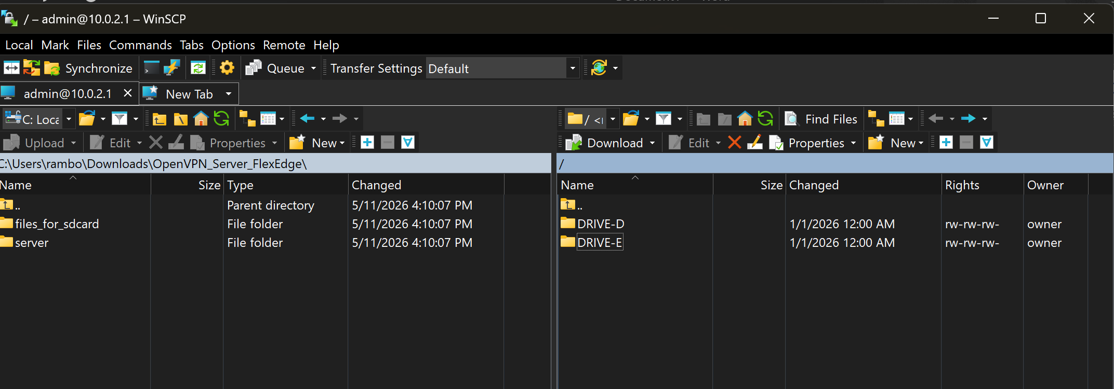

Copy all contents from the `files_for_sd_card` folder to Drive-E on the FlexEdge.
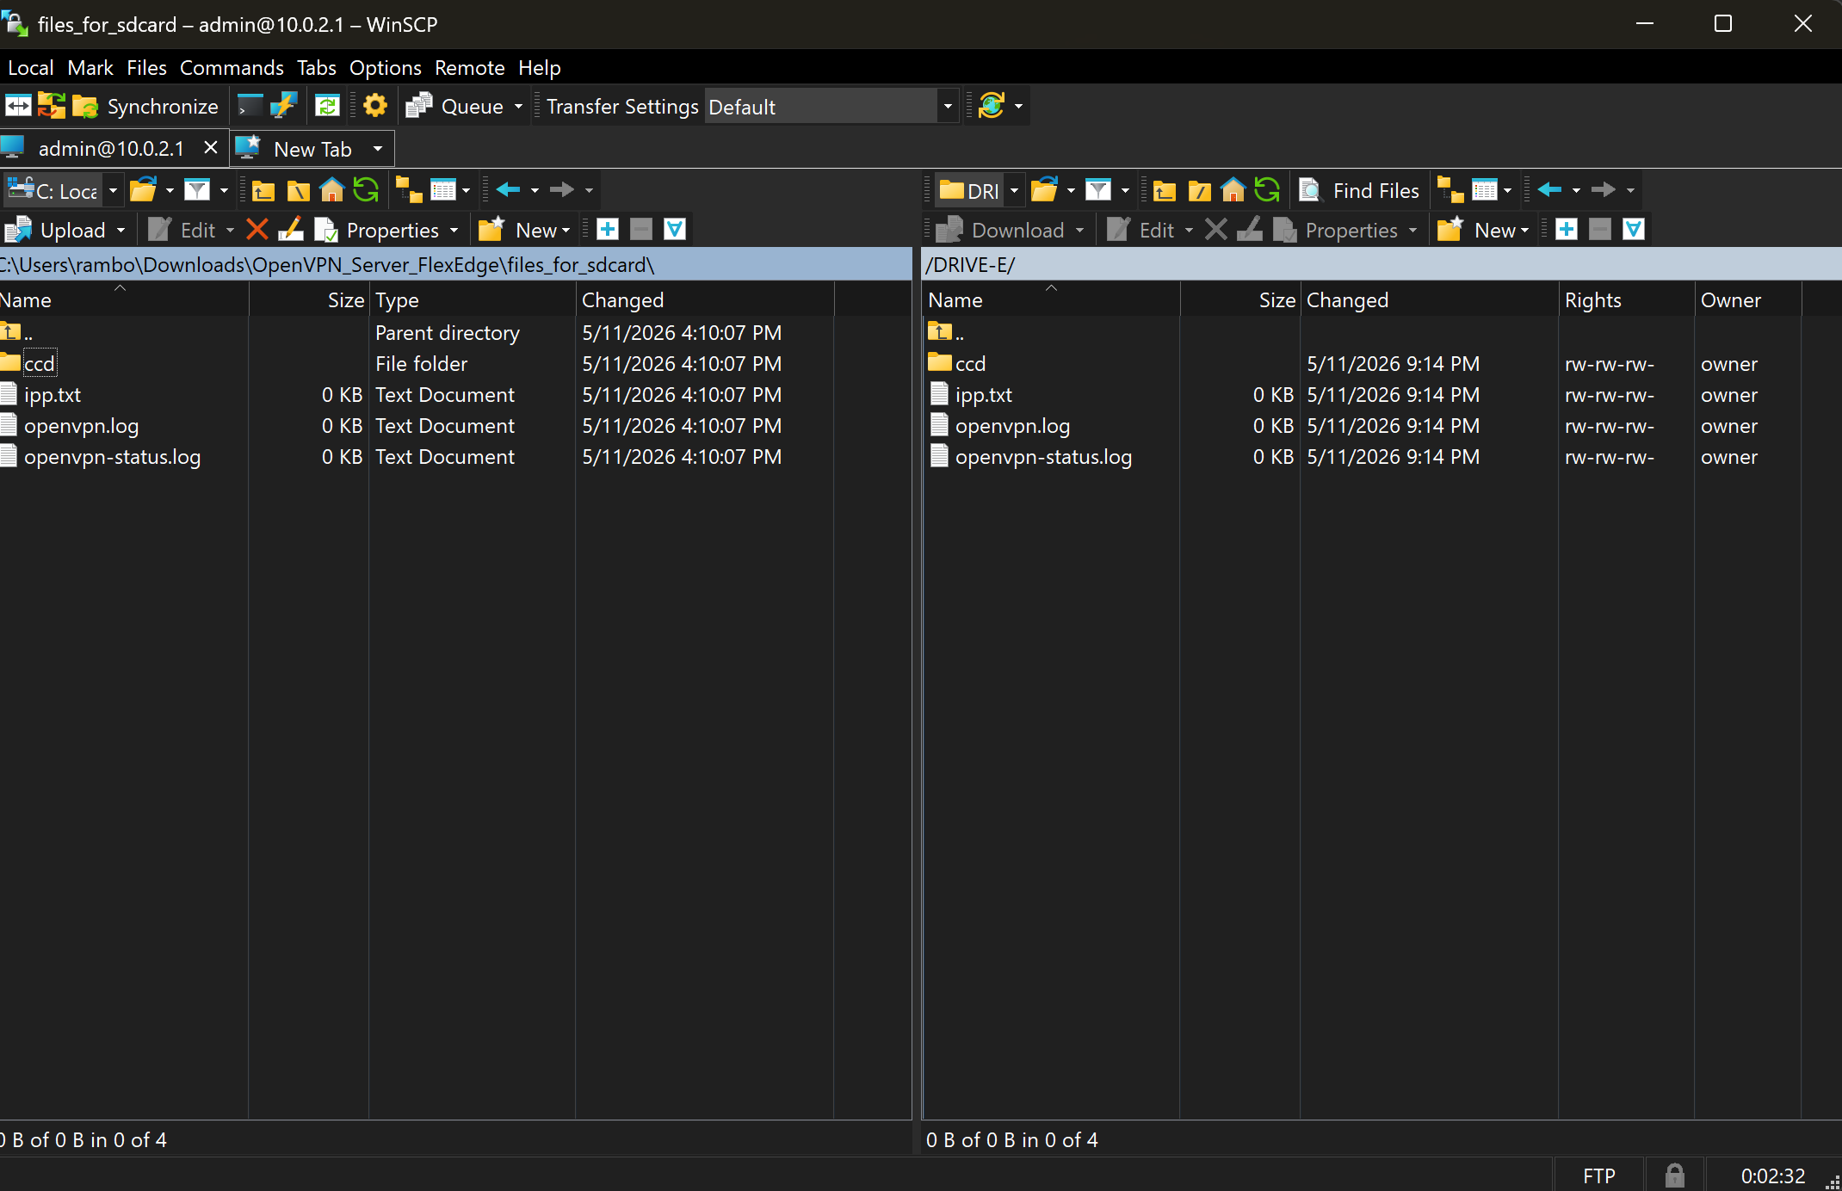

Navigate to Configuration>Hardware
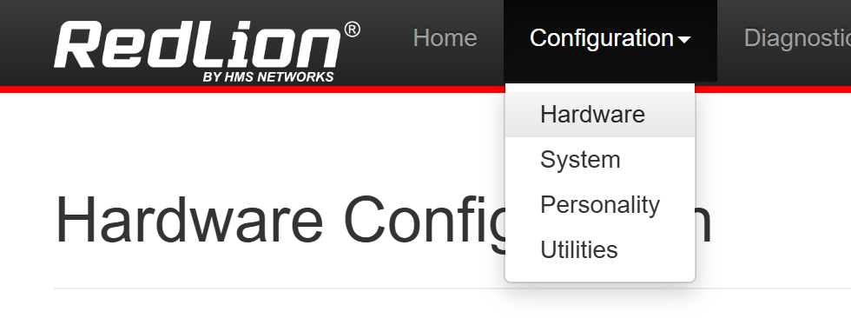

Under OpenVPN Tunnels, select ‘One’ from the dropdown menu.
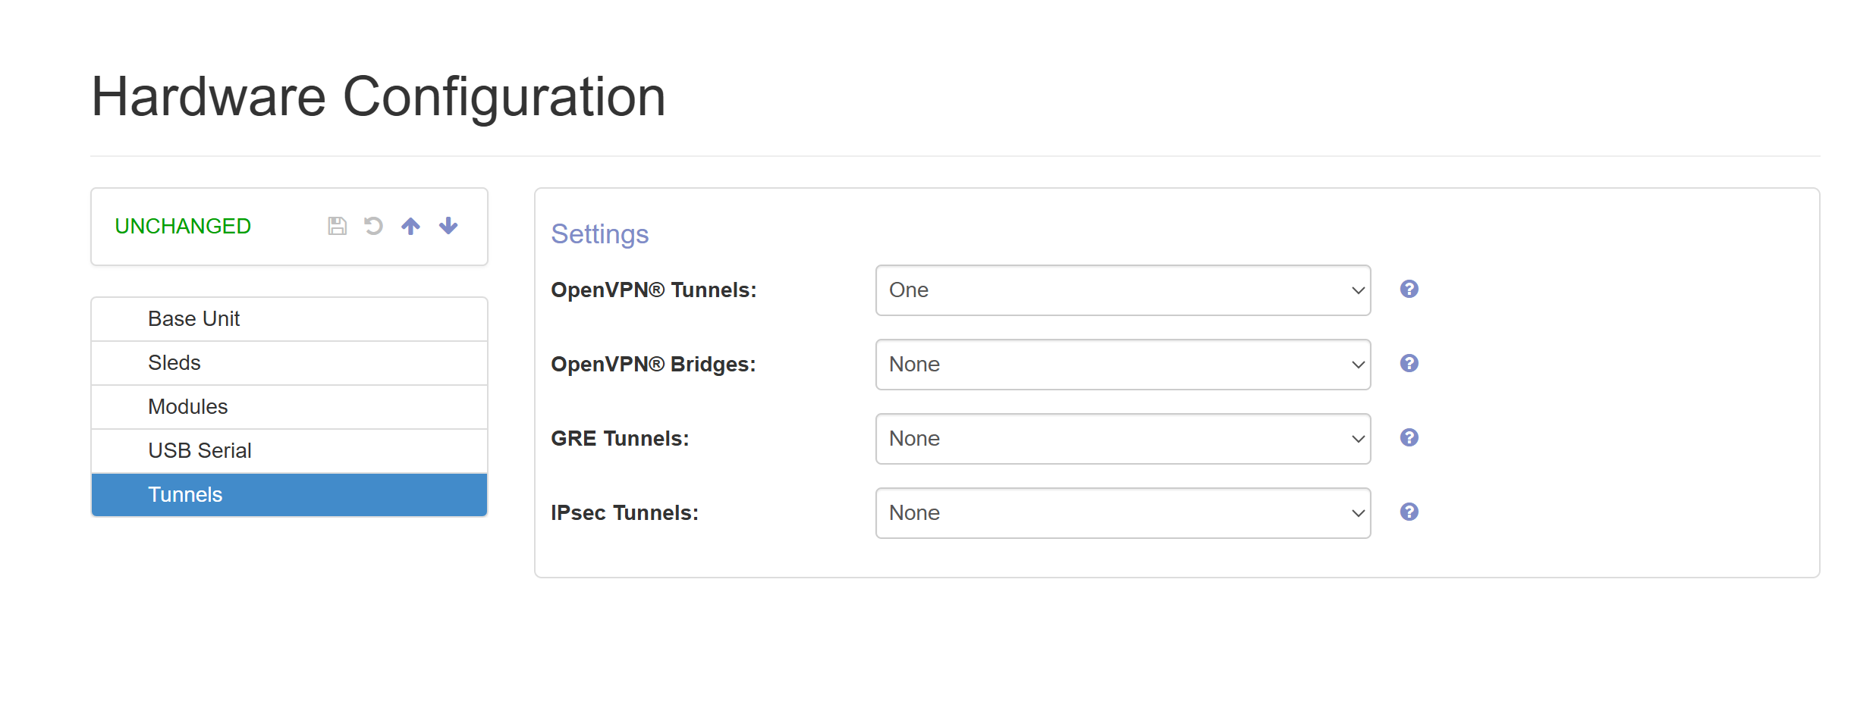
Navigate to Configuration>System


Under System Configuration > Network > Tunnels > VPN1, set Tunnel Mode to ‘Config File’. Under Configuration File, click the Upload icon to browse for the `.ovpn` file.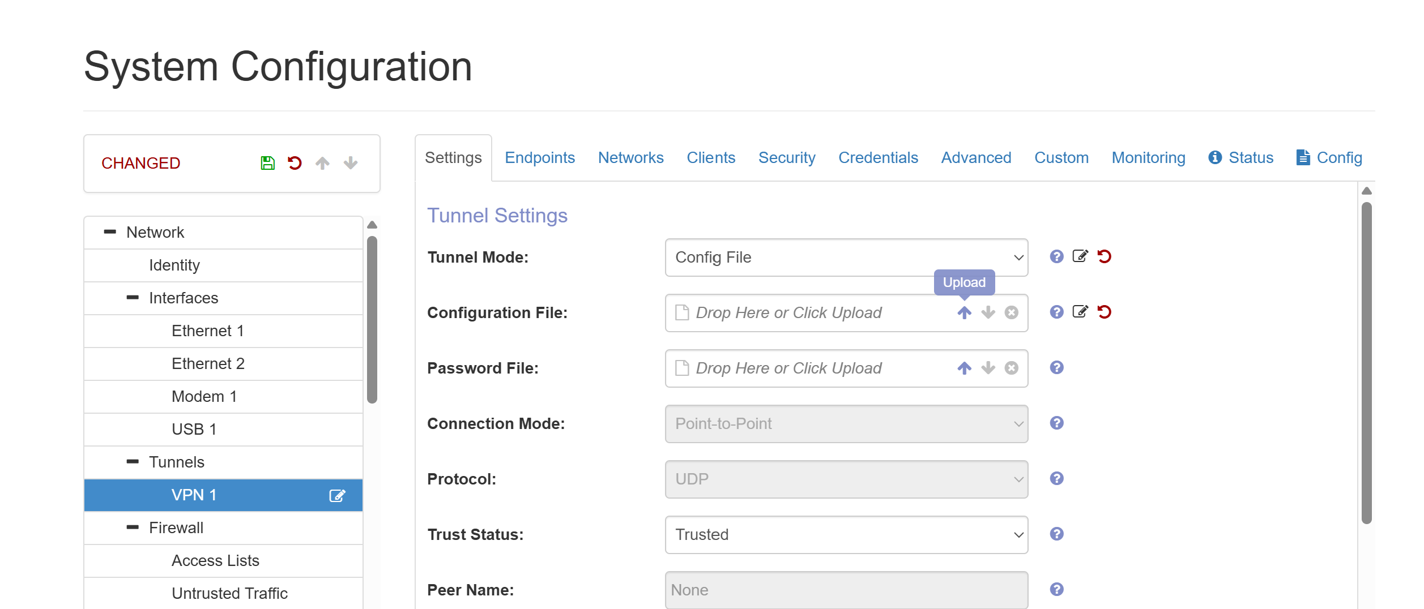

In the extracted package, navigate to the `server` folder, select the `. ovpn` file, and click ‘Open’.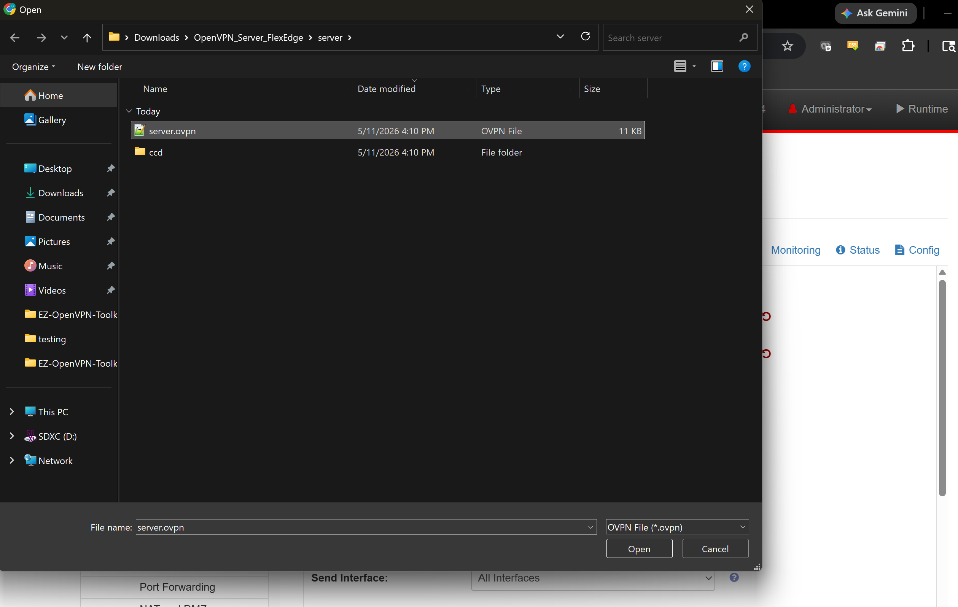

Ensure that ‘Trust Status’ is set to ‘Trusted’ and that ‘Send Interface’ is configured for the network interface that will accept incoming OpenVPN client connections. Then click the Save icon.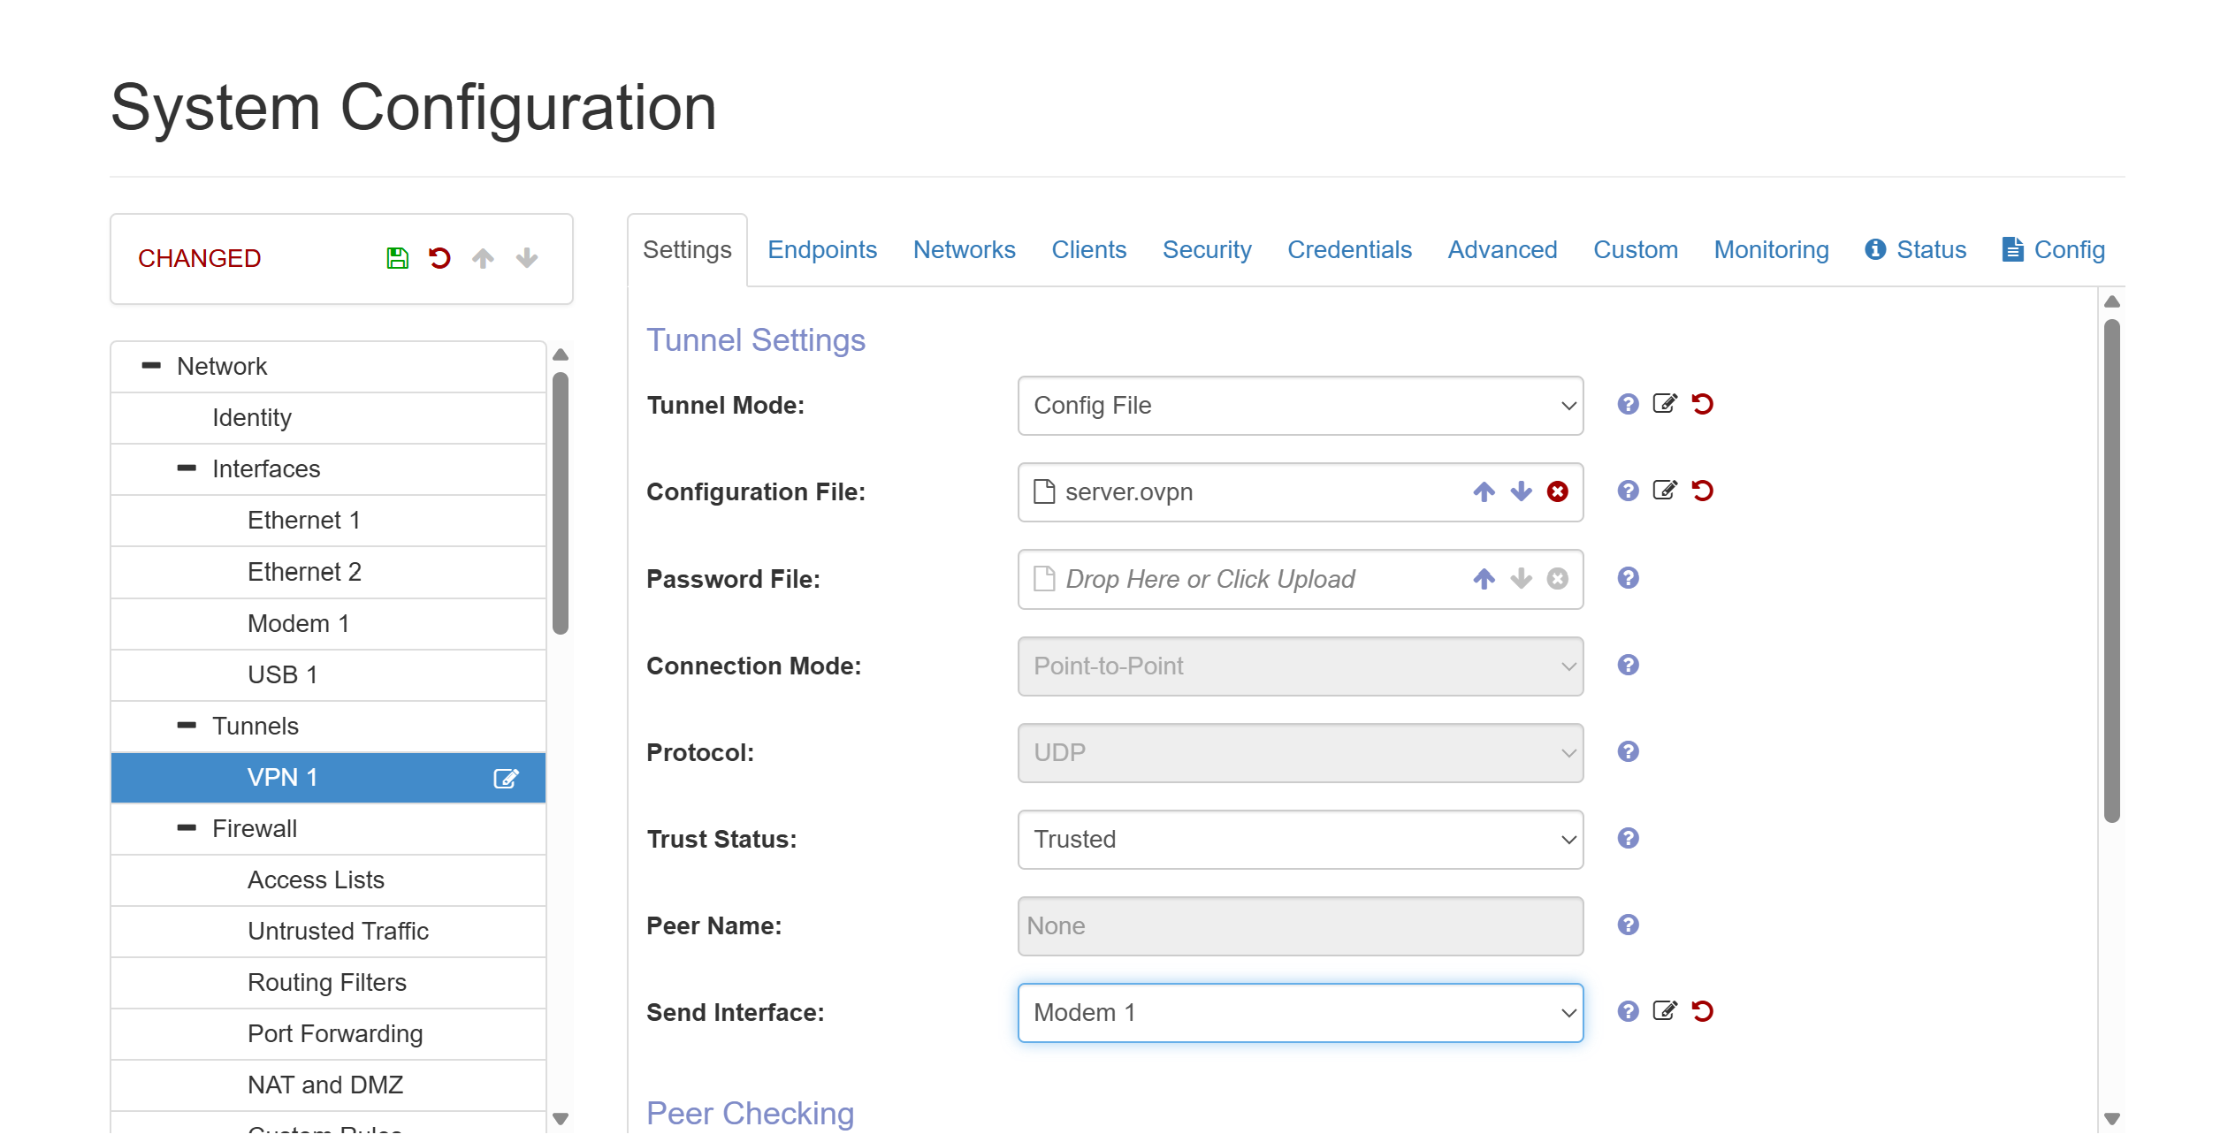

After clicking the Save icon, the serial number indicator should turn red, indicating that the configuration changes are being applied.
Once the configuration has been applied successfully, the serial number indicator will return to grey.Return to the Home page and verify that the VPN1 status shows ‘UP’.